**create 2 EC2 instance on 2 different regions and install nginx using terraform script**

**VI MAIN.TF**

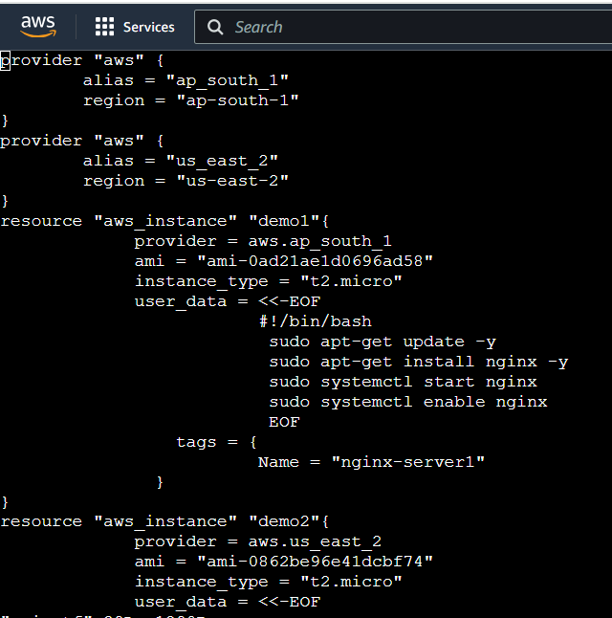

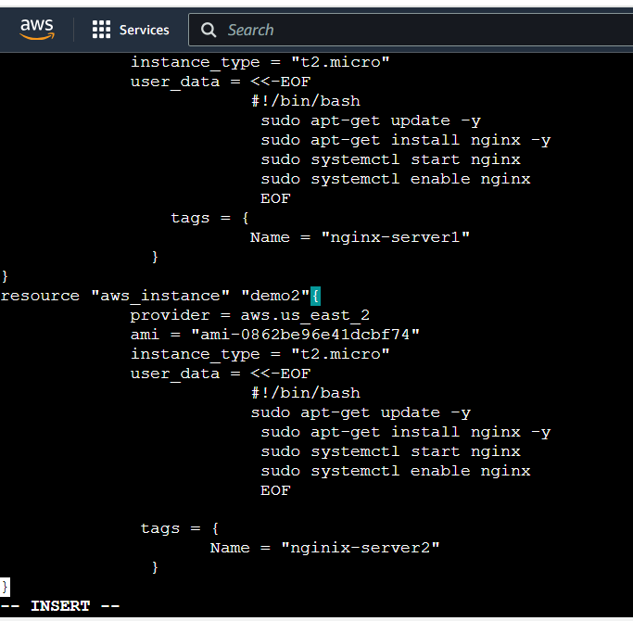

**NOW EXECUTE THE TERRAFORM FILE**

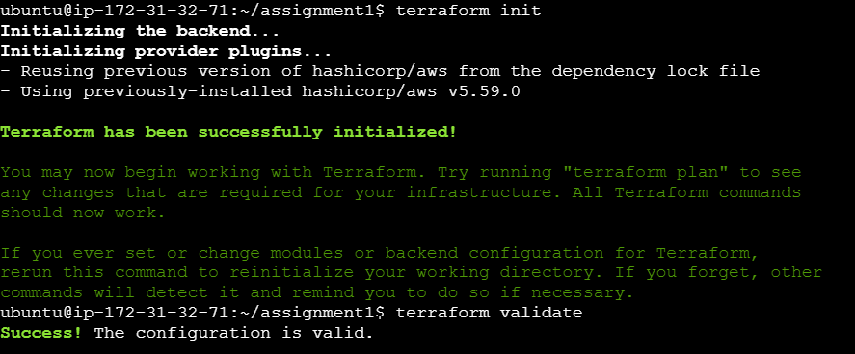

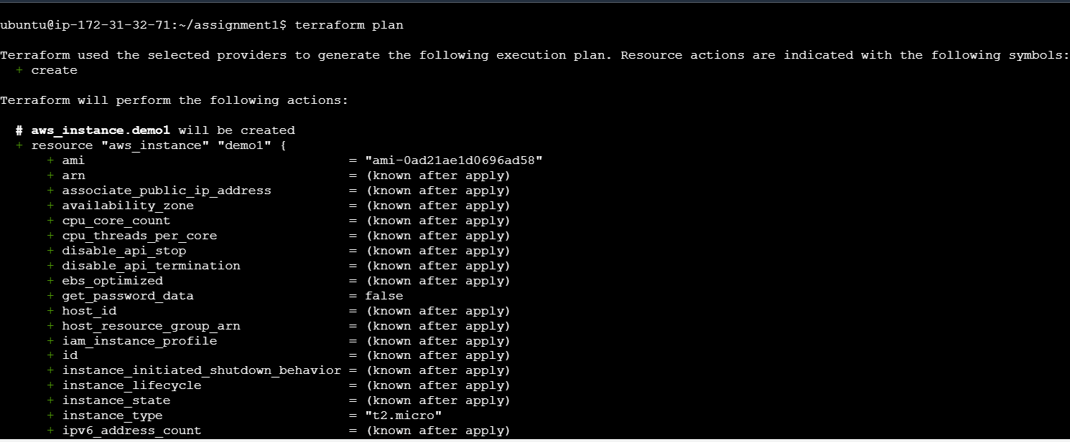

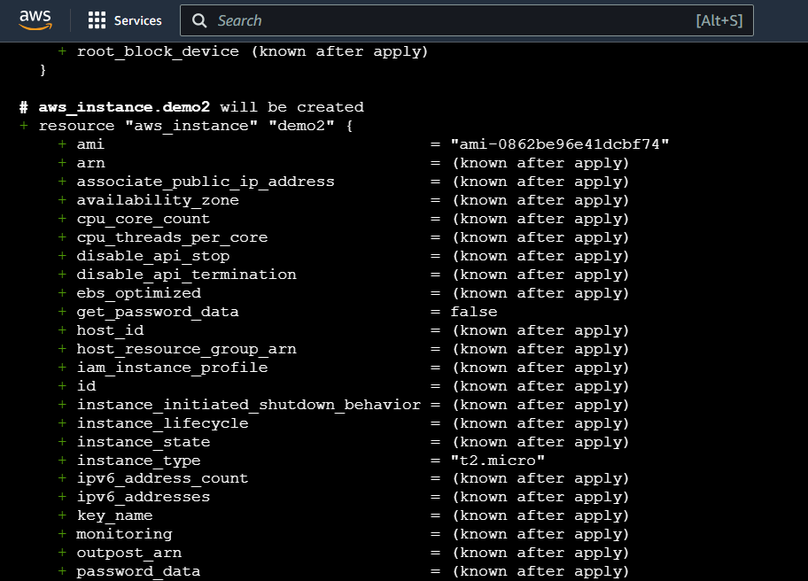

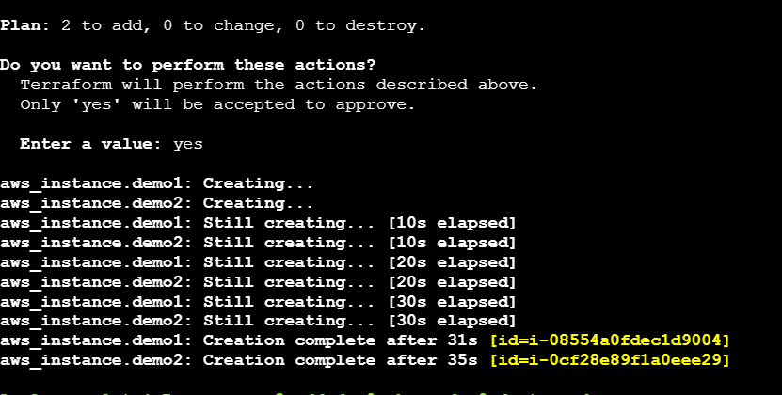

**TWO EC2 INSTANCE IN TWO DIFFERENT REGIONS HAS BEEN CREATED**

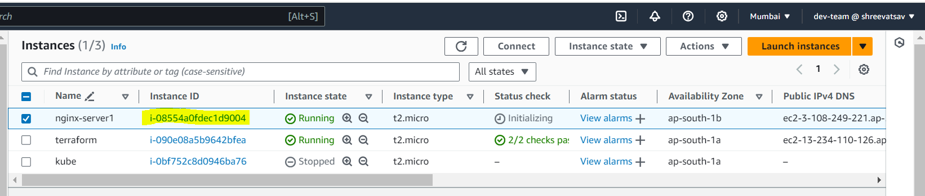

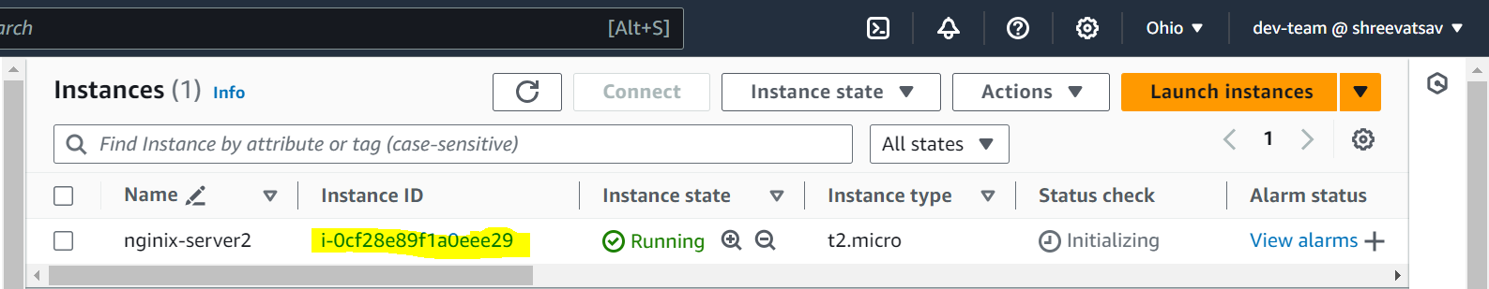

**NOW OPEN PORT NO 80 IN THESE EC2 INSTANCE AND CHECK WHETHER THE NGINX IS INSTALLED BY ACCESSING THE IP ADDRESS**

**NGINX-SERVER 1 IP ADDRESS**

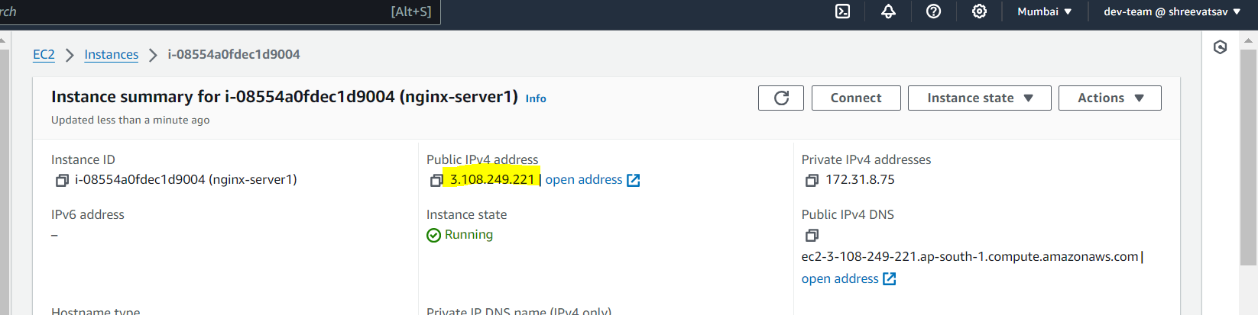

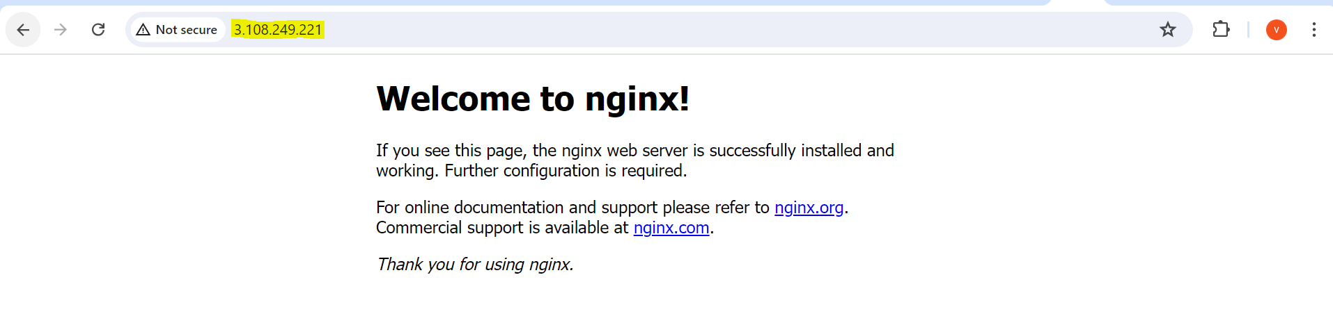

**NGINX-SERVER 2 IP ADDRESS**

